MEDICARE DESCRIPTION AND PROCEDURE CODES:
- STANDARD POWER OPERATED VEHICLE GROUP1:K0822#1
- BATTERY E2365 #2

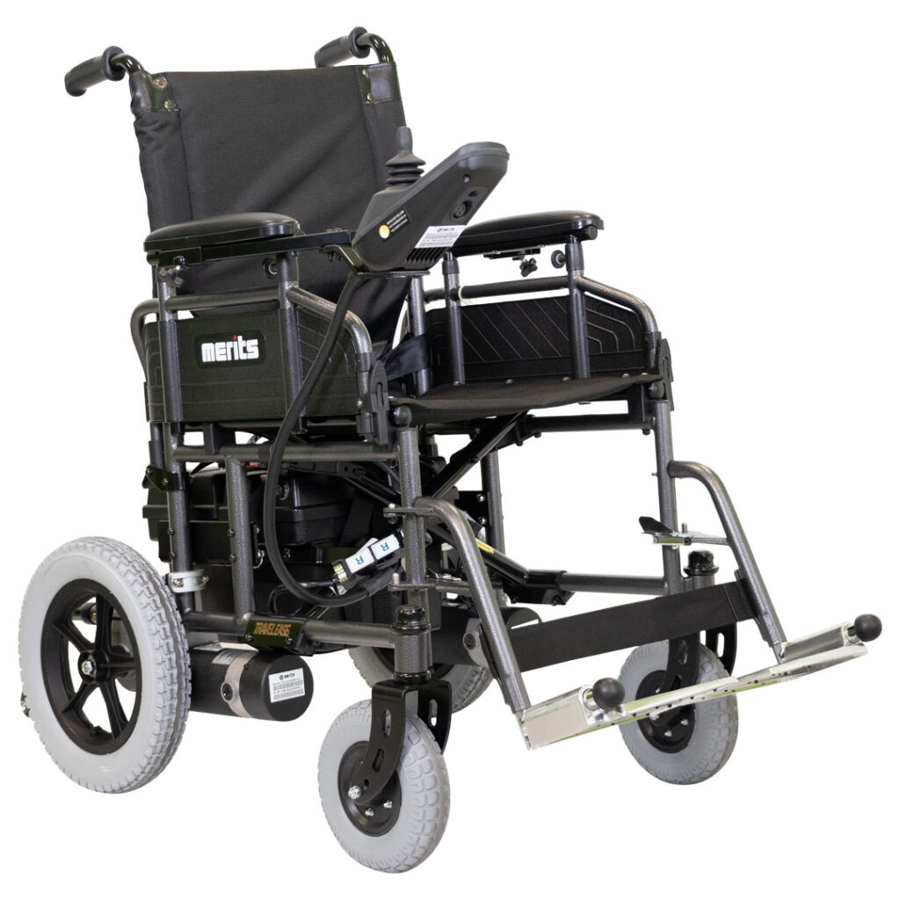

Features:
12.5-inch knobby drive tires for superior traction
• 4.8-inch ground clearance for easy obstacle clearance
• Height-adjustable flip-up armrests and swing-away footrests
• Foldable for improved storage and transportation
• Seat sizes available: 16, 18 or 20-inch
• Weight of the heaviest piece: 82 lbs.

Key Details:
K0822 Weight Capacity: 300 lbs.
Range: Up to 18 miles

Options:
Elevating legrests
USB charger
Oxygen tank holder
Seat cushion
Weather cover
Swing-away joystick

**Patient Agreement:** I, ___________________________________ (Patient Name), acknowledge that I have reviewed the power scooter depicted in the accompanying picture. I understand its features and specifications and agree that this wheelchair meets my mobility needs as assessed by my healthcare provider. I consent to accept and use this specific power wheelchair as part of my mobility solution.

Patient’s Signature:__________________________________________________________ Date:_____________
Signature if other than patient:___________________________________Relationship:____________________
Name if other than patient:______________________________________________________________________
Reason patient is unable to sign:__________________________________________________________________
Evaluator’s Signature:_____________________________________________________ Date:________________
Evaluator’s Name (printed):_____________________________________________________________________

